NAME: **NDAYAMBAJE Elie**

Reg no. **21RP05066**

Email**:** [**eliendayambaje12@gmail.com**](mailto:eliendayambaje12@gmail.com)

RP IPRC MUSANZE

**Topic: modern floods detection system**

**Abstract:** Most people around the world at least 80% loss of their lives in that case in flooding disaster is the most widely problem located in the overpopulation like village because of the different parameters such as heavy rainfall, dam breaks, overflow river and melting ice. In this proposal there is the system that used to detect or giving the signal to some people who lives in that location when the floods disaster is occur by using Arduino uno, sensor with the detect the content or level of water and buzzer or led send signal to show what happen.

**Keyword:** Arduino uno, sensor, buzzer and led

**Chapter 1: introduction**

During flood detection and warning system the floods are dangerous and devastating. One of the words most damage especially economic is caused due to floods. Floods are mainly caused due to heavy rainfall or increased water flow rate. Floods can not be measured solely using increased height of water because the width of river and topology of river channel also matter, one thing we can do is use flow rate as a direct measure to detect flooding. We also use soil moisture sensor to find volumetric water content of soil and using rainfall level, we can detect floods due to heavy rainfall. Also measuring volumetric water content can be used to asses drought, agricultural productivity, weather forecast and also floods obviously. I select that system to help them their lives.

**A flood** is a natural disaster where the condition of the land is temporary It is usually dry, and then filled with water. These natural disasters often occur in some parts of the world during the rainy season it can fall too much or too often causing damage to the population and disrupts social and economic activities. There are a few things that can cause a Floods are rain, overflowing rivers, dam breaks, melting ice caps and tsunamis. A flash flood can occur when heavy rain falls over a short period of time or over a period of time. rain for several days or weeks. Water usually flows from high places to low places

Mostly**floods** occur due to the heavy rainfall, from the melting of ice and snow on mountains, or from the combination of all these when exceeds water carrying capacity of the Lake, River or Sea into which it flows. One of the major factors is the Geographical location that causes a flood to occur. Because of the Floods, precious lives including humans and animals, properties that worth millions are found destroyed.

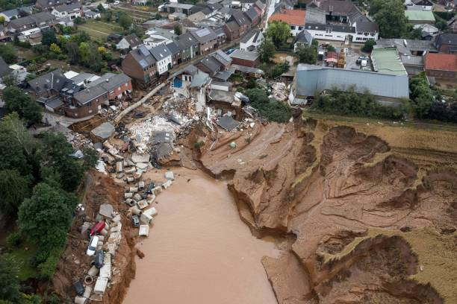

**Figure (1): floods occur in the rural area**

Due to Floods, the roads are destroyed, road traffic becomes jam. The telecommunication systems are destroyed so that there left no way of communication. The diseases are spread, the Agricultural setup is so badly damaged that it takes a lot of time to bring it again into normal condition. There are thousands of situations then the local people don’t have the knowledge of flood occurring, due to which the people never get a chance to shift to a safer place, due to which they lose their loved ones, their important stuff at home, the animals, etc

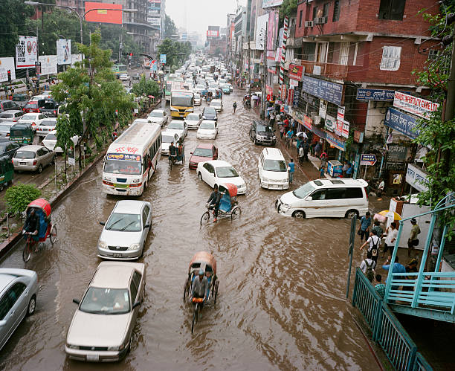

**Figure (2): floods occur in the urbarn area**

* 1. **Back ground**

In the previous system there are many methods used to handle that problem like using dam and water speel way to that dam, when it is rainfall occur. As automation future engineer we have seen that method used to hold water like dam, it can cause over flow water from that dam and we developed the system using Arduino, moisture sensor, led and buzzer for the purpose to inform some people when the floods occur.

* 1. **Problem statement**

The rains, from April to May every year. There is a problem of flooding in some parts of the world or the regions where we live It is caused by heavy rains every day and continues to flood the river places that are flooded with water large numbers of people are losing their lives, infrastructure is collapsing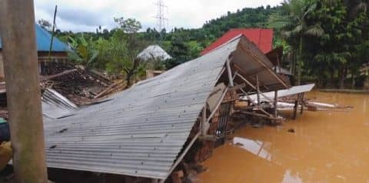

**Figure (3): this picture shows the floods disaster**

* 1. **objectives**

* + 1. **General objectives**

The general objectives is to determine the content or level of water and show where it located floods is often occur based on the level of water that moisture sensor is sensed, so that it be better to give the solution.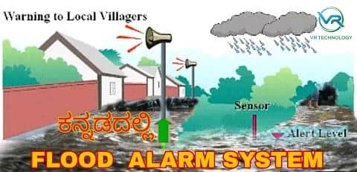

**Figure (4): this system used to show us where the floods disaster is often occurs**

* + 1. **Specific objectives**
* To help society in different activity
* To give the solution of problem takes long time with out seen it when searching where it located
* To fight against loss of lives and property occur from floods

**Chapter 2: Methodology**

This system will work on the system that are the following analysis that can be proven that according to the equipment.

* Arduino uno board AT mega 328 that gives the supply to the device it is electronic device platform
* Sensor that are used to detect the content or level of water into the soil
* Buzzer will send signal (sound) according to the sensor is sensed or when floods occur
* Led will give up light when the floods occur

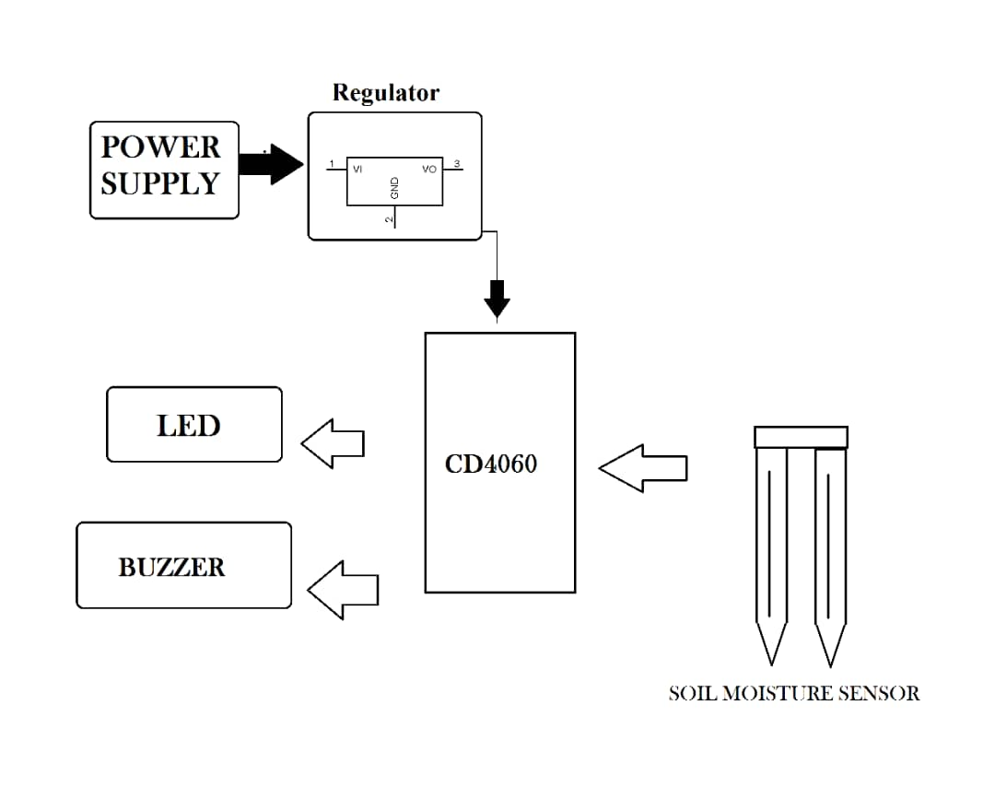

**Figure (5): block diagram of that system**

**2.1. The Components Required for the modern floods detection System**

This project requires very few components and the connection is also very simple. The components are listed below:

•Arduino uno board

•Bread board

•soil moisture sensor

•Buzzer

•Led

•Connecting wires/ Jumper wires

•9vdc battery

* **Arduino uno board:**

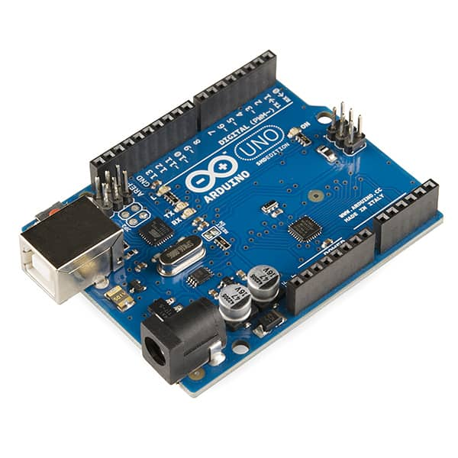

**Arduino uno** is an opening source programmable circuit board that can be integrated into a wide variety of makerspace projects both simple and complex.

• This board contains a microcontroller which is able to be programmed to sense and control objects in the physical world

Arduino Uno is a microcontroller board based on the ATmega328. It has 14 digital input / output pins (of which 6 can be used as PWM outputs), 6 Analog inputs, 16 MHz ceramic resonator, USB connection, power jack, ICSP plug, and a reset button. It contains everything needed to support the microcontroller; simply use the USB cable or power it with AC-to-DC adapter or battery is connected to a computer begins.

* **Moisture Sensor**

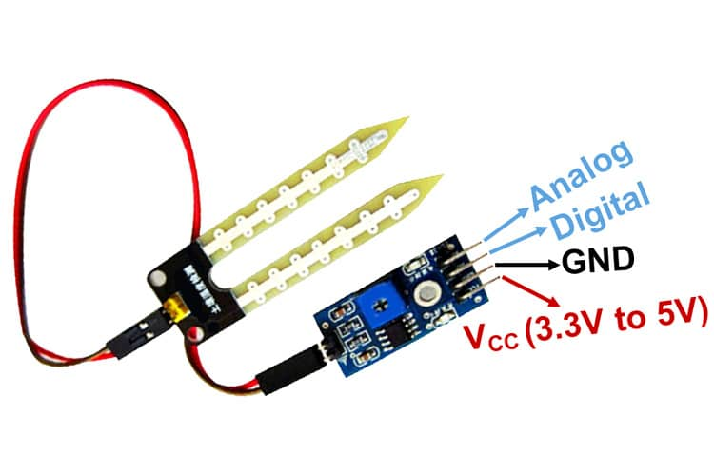Soil moisture sensor measures the soil water content in the soil and can be used to estimate the amount of stored water in the soil horizon. working of the soil moisture sensor is very easy to understand. It has 2 probes with exposed contacts that act like a variable resistor whose resistance varies according to the water content in the soil. This resistance is inversely proportional to the soil moisture which means that higher water in the soil means better conductivity and hence a lower resistance. While the lower water in the soil means poor conductivity and will result in higher resistance. The sensor produces an Analog voltage output according to the resistance.

The sensor comes with an electronic module that connects the probe to the Arduino.

• Soil resistivity in this particular project, we will use the soil moisture sensors which can be inserted into soil to measure the soil moisture water content

•This soil moisture sensor will be used to measure the level of water for the purpose is to make sure if floods it is occur

* **Breadboard**

• A breadboard, solderless breadboard, or protoboard is a construction base used to build semi-permanent prototypes of electronic circuits. Unlike a perf board or stripboard, breadboards do not require soldering or destruction of tracks and are hence reusable.

• A breadboard is a simple device designed to let you create circuits without need for soldering. The breadboard which has many holes int which circuit components like ICs and resistors can be inserted. A typical breadboard is shown below:

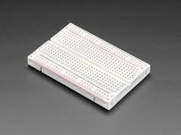

* **Buzzer**

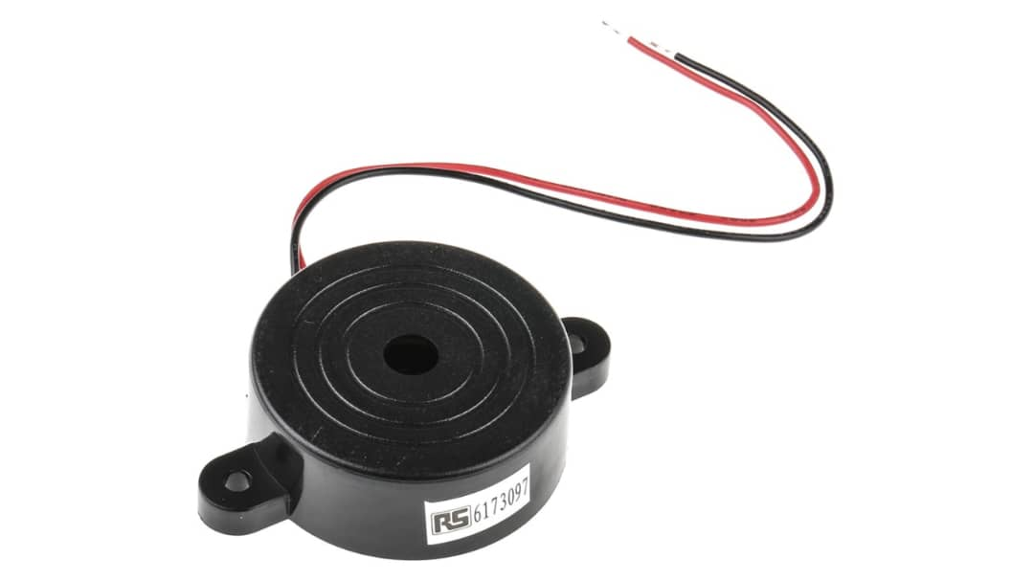

buzzer is an electrical device that is used to make a buzzing sound as signal for example, to attract someone's attention.in this project when the floods disaster is often occur, that buzzer will giving sound as signal to show that problem happens.

* **Led**

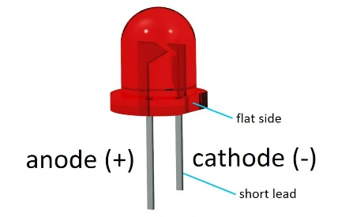

In the simplest terms, a light-emitting diode (LED) is a semiconductor device that emits light when an electric current is passed through it. In this project we use this Led will giving a light as signal that show some people who living in this area there is floods problem, those peoples will know before time and then flee to another place.

* **9v battery:**

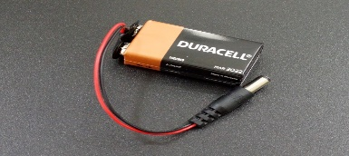

Arduino can be powered up using a 9v battery. there are several ways through which we can power an Arduino board and one is using a 9v external battery. Using 9v battery we can make the Arduino project portable with out any need for an extra power source.

To power the circuit, I am using an external Battery. You can use any 9v or 12-volt battery. The battery is connected to the Vin and ground pins of Arduino

* **Connecting wires:**

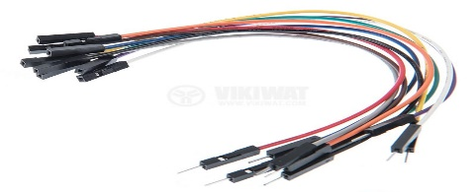

* A connecting wire allows travels the electrical current from one point to another point without resistivity.
* A jumper wire is an electric wire that connects remote electric circuits used for printed circuit boards. By attaching a jumper wire on the circuit, it can be short-circuited and short-cut (jump) to the electric circuit.

**2.2 Assembling or how to make circuit diagram of modern floods detection system**

Arduino Soil Moisture Sensor Circuit – Connection Diagram

Now that we have a complete understanding of how a Soil Moisture sensor works, we can connect all the required wires to the Arduino UNO board. This section of the article will be divided into two parts, one shows Analog output and another one shows the digital output. Let's begin with Analog circuitry-

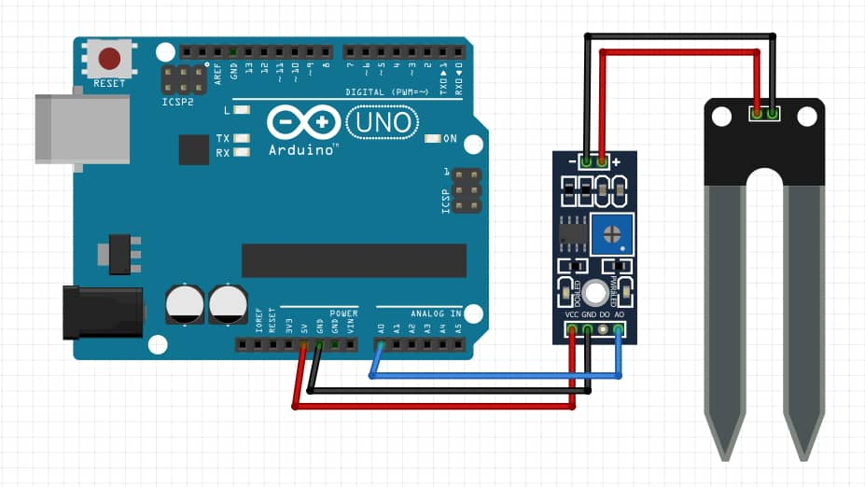To work with sensors we need to power the sensor first, for that we are using the 5V and GND pin of the Arduino UNO Board.

As shown in the above Arduino soil moisture sensor circuit diagram we have connected an LED to digital PIN 3 of the Arduino and the Analog out pin of the sensor is connected to the A0 pin of the Arduino UNO board, finally, the ground is common between the LED and the sensor. We will program the Arduino so that the brightness of the LED will change depending on the soil moisture data sensed by the probe.

For the digital interface part, we are also using the +5V and Ground from the Arduino to power the sensor module. Connecting a soil moisture sensor to Arduino or any other microcontroller is pretty simple. As we all know the sensor outputs both Analog and digital signals so processing this signal is very easy.

**2.3. Explanation the source of code and upload this code to Arduino**

**2.4. circuit diagram of floods detection system**

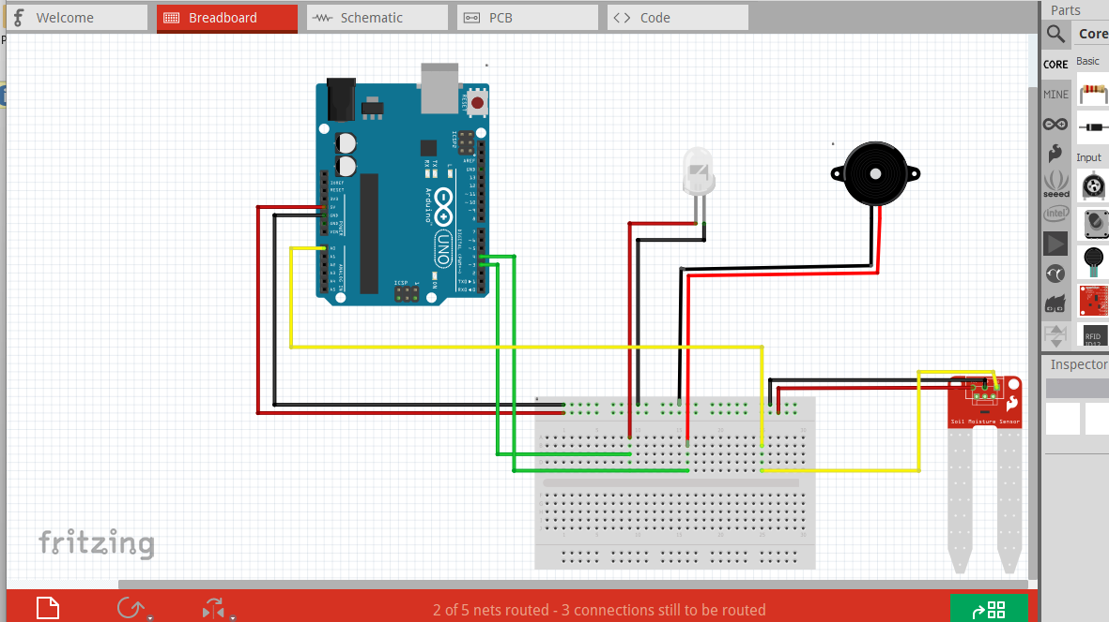

This circuit he used an Arduino uno, led, buzzer and sensor, so this sensor will be used to sense the level of water in the soil otherwise it will give information to the Arduino, when it rains a lot or there is an overflow river that can cause a floods in the area to show that there was In case of flooding, he will use LEDs and buzzers that will give a signal depending on the level of the water sensor has sensed, the sensor will tell the buzzer and LED to be high when the sensor input is high. signals will be given from buzzer and led to notify those peoples.

after making a circuit of the modern flood detection system We realized that the system will help us to notify the people living in this area that there is a flood problem using a buzzer and LEDs that will provide information to some of the residents according to what the sensor has sensed. when it rains a lot there may be a problem of flooding. so that the people who live in the area will know before time that the flood disaster happens at night without them knowing the buzzer will give a sound or signal and the LED will give light and the people flee to another place. this system will help us to protect people's lives from the possible effects of floods

**3.0. conclusion**

as a conclusion based on the above in our system, it is better to use this system because it will help us to inform the people living in the area that there has been a flood problem before time, especially it will help us to notify the flood disaster to the people who live there during the night by using a buzzer that will give sound and the led will give light as a signal to show that the problem of flooding has happened so that we can save people's lives and their activities

so I would encourage everyone to use this system because many have lost their lives due to not knowing that there was a flood problem during the night